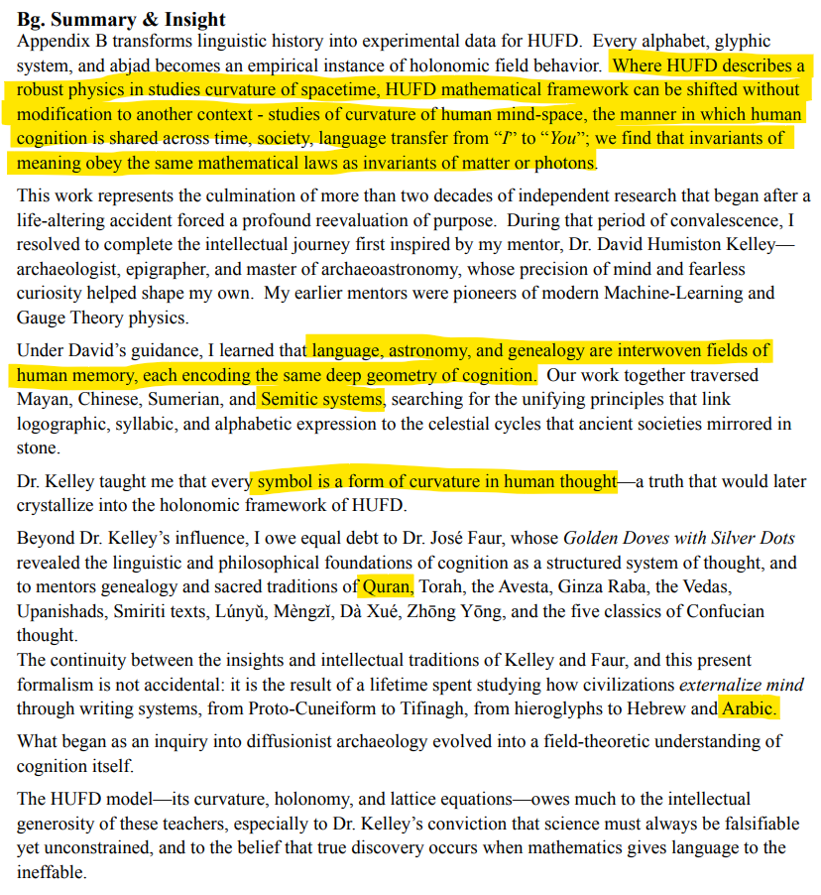

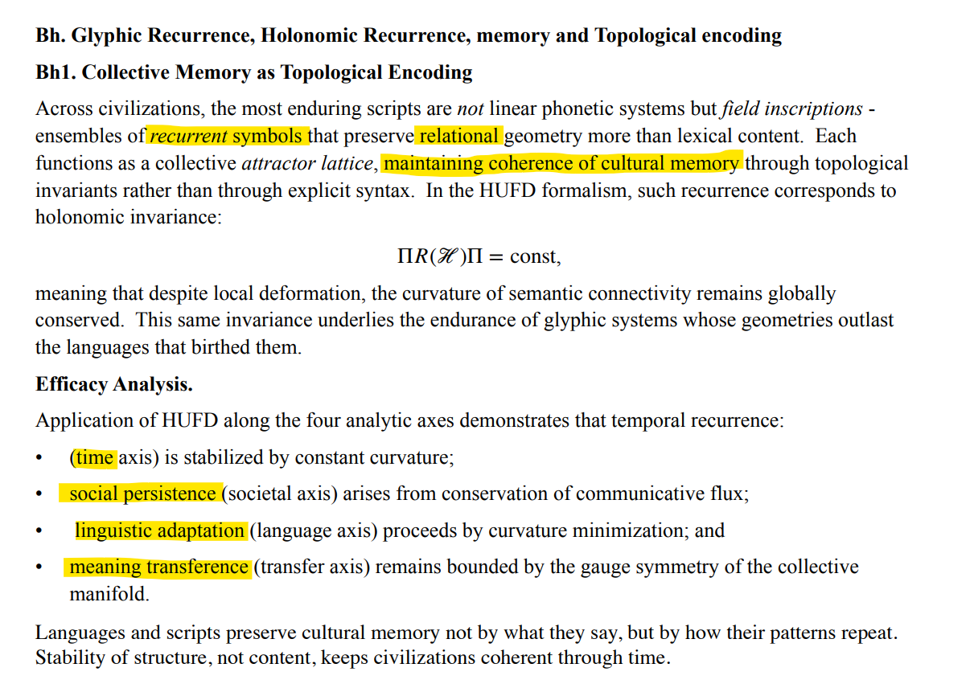
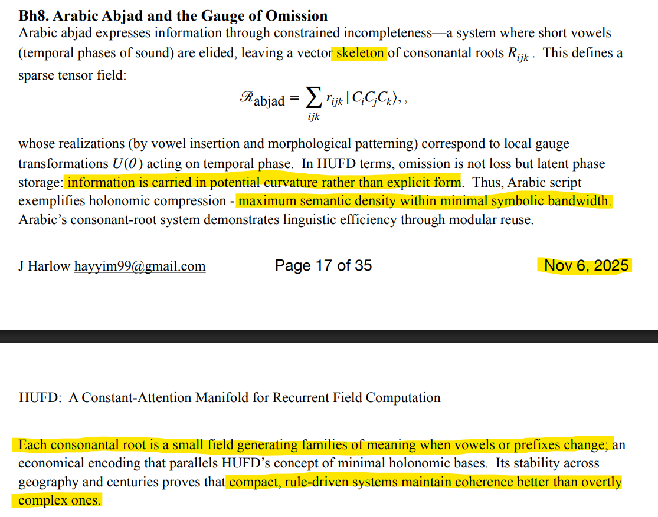
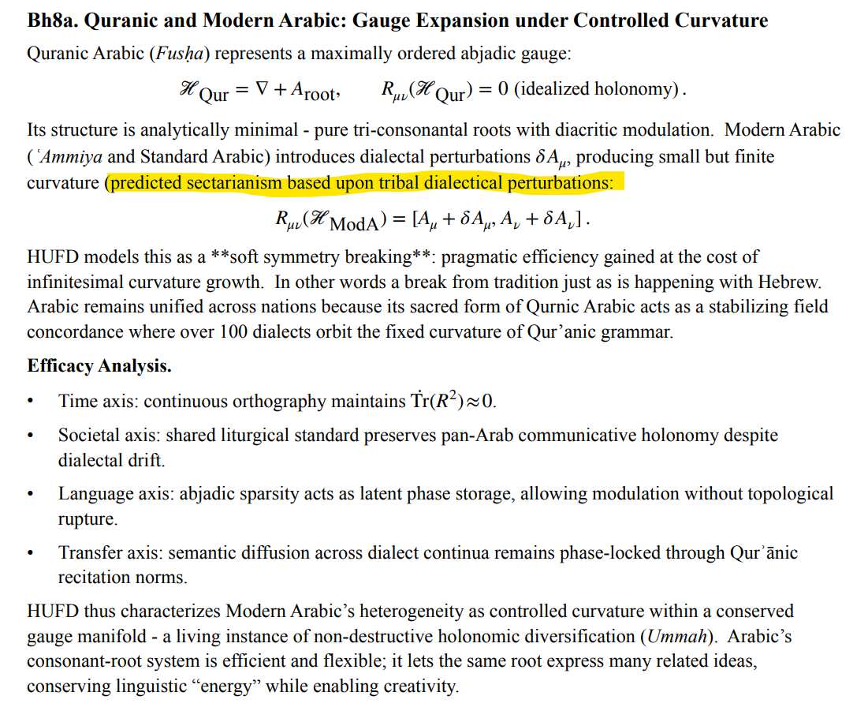

brother Harlow,

I had not taken your statement as an insult! I really appreciate your reply. I'm new to some of the formalisms and spent a few hours trying to simulating the geometry and dynamics in my head.

Now that what you meant by recursion is clearer to me, I recognize that I'm familiar with the pattern.

Concatenated:
H-S-H-S
dh-b-dh-b
r-f-r-f
z-h-z-h
z-l-z-l
s-l-s-l
S-f-S-f
S-l-S-l
3-s-3-s
k-b-k-b
l-ء-l-ء
h-d-h-d
w-s-w-s
Non-concatenated
kh-n-z-r
d-r-h-m
z-kh-r-f
s-n-b-l
s-r-b-l
Q-r-T-S
Q-s-T-s

